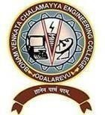

B VC ENGINEERING COLLEGE (A)-22, ODALAREVU
ODALAREVU, ALLAVARAM MANDAL, ANDHRA PRADESH – 533210
Approved by AICTE with PIO/Foreign National Status, New Delhi, Permanently Affiliated to JNTUK, Kakinada and Accredited with NAAC
Tel: 08856-250345-Ext 277, Fax: 08856-25088 www.bvcec.edu.in
==========================================================================

DEPARTMENT OF ARTIFICIAL INTELLIGENCE AND MACHINE LEARNING (AI&ML)

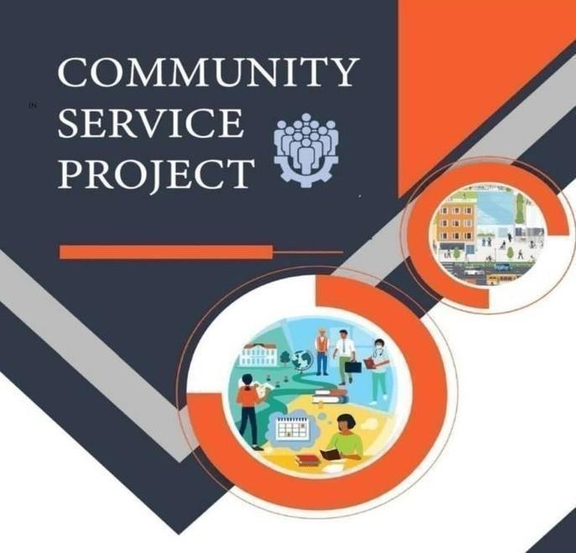


ANDHRAPRADESH
STATE COUNCIL OF HIGHER EDUCATION COMMUNITY SERVICEPROJECTPROGRAM

Agriculture

A Community Service Project report submitted towards partial fulfillment of the requirements for the award of the degree of

BACHELOR OF TECHNOLOGY
IN

ARTIFICIAL INTELLIGENCE AND MACHINE

LEARNING (AI&ML)

Submitted by

Kanuri Jagan Satya Sai 23225A6103
Under the Esteemed Guidance of
Ms.Ganji Lakshmi
M.Tech.

Assistant Professor
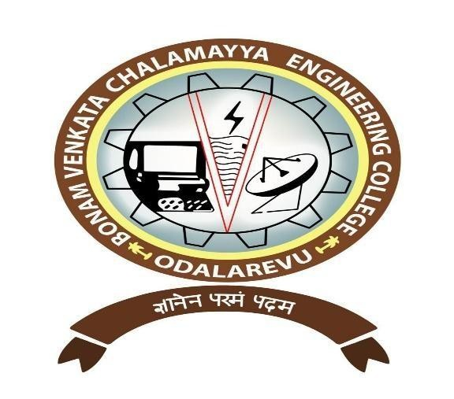
DEPARTMENT OF ARTIFICIAL INTELLIGENCE AND MACHINE
LEARNING (AI&ML)
BONAM VENKATA CHALAMAYYA ENGINEERING COLLEGE

(AUTONOMOUS)
(Approved by A.I.C.T.E, New Delhi & Permanently Affiliated to J. N.T.U.K, Kakinada)
(Accredited by N.B.A & NAAC with ‘A’ Grade)
ODALAREVU – 533210
2022-2026

BONAM VENKATA CHALAMAYYA ENGINEERING COLLEGE (AUTONOMOUS)
(Approved by A.I.C.T.E, New Delhi & Permanently Affiliated to J. N.T.U.K, Kakinada)
(Accredited by N.B.A & NAAC with ‘A’ Grade)

DEPARTMENT OF ARTIFICIAL INTELLIGENCE AND MACHINE
LEARNING (AI&ML)

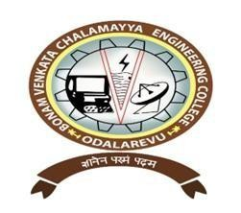

CERTIFICATE

This is to certify that the Community Service Project work entitled“Agriculture” is a bonafide work carried out by Kanuri Jagan Satya Sai (23225A6103) in the fulfillment of the requirements for the award of the degree of the Bachelor of Technology in ARTIFICIAL INTELLIGENCE AND MACHINE LEARNING
(AI&ML) during the period March 2026 - April 2026.

Faculty Mentor Head of the Department
Ms.Ganji Lakshmi Dr. A. Rama Krishna
M.Tech., M.Tech., Ph.D.,
Assistant Professor Professor & HOD

BONAMVENKATACHALAMAYYAENGINEERING COLLEGE (AUTONOMOUS)
(Approved by A.I.C.T.E, New Delhi & Permanently Affiliated to J. N.T.U.K, Kakinada)
(Accredited by N.B.A & NAAC with ‘A’ Grade)
DEPARTMENT OF ARTIFICIAL INTELLIGENCE AND MACHINE
LEARNING (AI&ML)

CERTIFICATE

The Community Service Project work entitled “Agriculture” has been examined and evaluated by the following panel of the examiners on April 2026.

Faculty Mentor Co-ordinator Head of the Department
Ms.Ganji Lakshmi Mr.B.NARASIMHA RAO Dr. A. Rama Krishna
M.Tech. M.Tech.(Ph.D) M. Tech, Ph. D
Assistant Professor Associate Professor Professor & HOD
Dept. of (AI&ML) Dept. of CAD,AI&ML,CSM Dept. of CAD,AI&ML,CSM

BVC ENGINEERING COLLEGE (A)-22, Odalarevu
ODALAREVU, ALLAVARAM MANDAL, ANDHRA PRADESH – 533210 Approved by AICTE with PIO/Foreign National Status,
NewDelhi, Permanently Affiliated to JNTUK, Kakinada and Accredited with NAAC Tel: 08856-250345-Ext 277, Fax:0885625088 www.bvcec.edu.in
==========================================================================
=

PREFACE OF COMMUNITY SERVICE PROJECT PROGRAM REPORT

NAME OF THE DEPARTMENT: Artificial Intelligence & Machine Learning
BATCH | : 2022-2026
ACADEMIC YEAR | : 2025-2026
COURSE | : UG (B .Tech)
REGULATION | : BR-20.
YEAR & SEM | : IV YEAR & I SEM
PROGRAM NAME | : COMMUNITY SERVICE PROJECT

NAME OF THE DEPT. COORDINATOR: Mr.B.NARASIMHA RAO

Instructions to Students for Community Service Project

Please read the detailed Guidelines on Community Service Project hosted on the website of AP State Council of Higher Education https://apsche.ap.gov.in

Link: https://apsche.ap.gov.in/Pdf/Guidelines%20for%20the%20OJT%20Internship
%20Community%20Service%20Project.pdf

- It is mandatory for all the students to complete 2 months (180 hours) of Community Service Project as a part of the 10 month mandatory internship/on the job training.
- Consider yourself as a committed volunteer in the community, you work with.

- Every student should identify the village/community/habitation for Community Service Project
(CSP) in consultation with the College Principal/the authorized person nominated by the Principal.
- Report to the community/habitation as per the schedule given by the College. You must make your own arrangements of transportation to reach the community/habitation.
- You will be assigned with a Faculty Guide from your College. He/She will be creating a WhatsApp group with your fellow volunteers. Post your daily activity done and/or any difficulty you encounter during the programme.
- You should maintain punctuality in attending the CSP. Daily attendance is
compulsory.
- You are expected to learn about the community/habitation and their problems.

- Know the leaders and the officials of the community/habitation.
- While in project, always wear your College Identity Card.

- If your College has a prescribed dress as uniform, wear the uniform daily.

- Identify at least five learning objectives in consultation with your Faculty Guide. These learning objectives can address:
- Information about the community, including the realities and problems of the society.
- Need for creating awareness on socially relevant aspects/programs.

- Acquiring specific Life Skills.
- Learning areas of application of knowledge and technologies related to your discipline.
- Identifying developmental needs of the community/habitation
12)Practice professional communication skills with team members, and with the leaders and officials of the community. This includes expressing thoughts and ideas effectively through oral, written, and non-verbal communication, and utilizing listening skills.
  - Be regular in filling up your Program Book. It shall be filled up in your own handwriting. Add additional sheets wherever necessary.
  - At the end of Community Service Project, you shall be evaluated by the person incharge of the community/habitation to whom you report to.
  - There shall also be evaluation at the end of the community service by the Faculty Guide and the Principal.
  - Do not indulge in any political activities.

  - Ensure that you do not cause any disturbance to the inhabitants or households during your interaction or collection of data.
  - Be cordial but not too intimate with the persons you come across during your service activities.
  - You should understand that during this activity, you are the ambassador of your College, and your behavior during the community service programme is of utmost importance.
  - If you are involved in any discipline related issues, you will be withdrawn from the programme immediately and disciplinary action shall be initiated.
  - Do not forget to keep up your family pride and prestige of your College.
  - Remember that you are rendering valuable service to the society and your role in the community development will become part of the history of community.

Community Service Project Report

Submitted in accordance with the requirement for the degree of………….

Name of the College: Bonam Venkata Chalamayya Engineering College

Odalarevu.

Department: Artificial Intelligence and Machine learning
Name of the Faculty Guide: Ms.Ganji Lakshmi Duration of the CSP: From………To………
Name of the Student: Kanuri Jagan Satya Sai
Year of Study:2025-2026
Register Number: 23225A6103

Date of Submission:

Student’s Declaration

I, Kanuri Jagan Satya Sai, a student of UG (B.Tech) Program, Reg. No. 23225A6103 of the Department of Artificial intelligence & Machine learning , Bonam Venkata Chalamayya Engineering College do hereby declare that I have completed the mandatory community service from to in Community Agriculture, Mummidivaram under the Faculty Guideship of Ms.Ganji Lakshmi, Department AI&ML in College.

(Signature and Date)

Endorsements

Faculty Guide: Ms.Ganji Lakshmi

Head of the Department: Dr. A. Rama Krishna

Principal

ACKNOWLEDGEMENT

We express our heartfelt gratitude to BVC Engineering College (A)–22, Odalarevu, for providing us with this valuable opportunity to successfully complete our Community Service Project. The continuous support and encouragement from the institution have been instrumental in helping us achieve our goals.

We extend our sincere thanks to our project guide for her valuable guidance, constant support, and encouragement throughout the project. Her assistance and motivation have been vital in the successful completion of this work.

We also express our special thanks to Dr. A. Rama Krishna, Professor and Head of the Department of Artificial Intelligence and Machine Learning (AI&ML), and to all the Teaching and Non-Teaching faculty members of the department for their cooperation and for providing all the necessary facilities to carry out this project.

We are deeply grateful to our Principal, Dr. D. Maheswar Dutt (Ph.D., M.Tech., MSAE, MCI, MISTE), for his continuous motivation and for providing excellent infrastructure and resources that enabled us to complete this work effectively.

Finally, we would like to express our sincere appreciation to our parents and friends for their constant encouragement and support, and to the community members and villagers of Mummidivaram for their cooperation and contribution in helping us complete this project successfully. 9

ABSTRACT

Agriculture forms the backbone of the Indian economy and plays a crucial role in ensuring the nation’s growth and food security. Nearly 70% of rural households and around 10% of the urban population depend directly or indirectly on agriculture for their livelihood. India stands as a major global supplier of various agricultural commodities such as tea, coffee, rice, spices, oil meals, fruits, vegetables, meat products, and marine exports. The country also ranks among the largest producers of milk, and is the second-largest producer of wheat and rice worldwide.

Despite its importance, the agricultural sector faces numerous challenges. Farmers often struggle with low income, rising input costs, and unfavorable market conditions. The high cost of cultivation materials and inadequate support prices make it difficult for farmers to sustain their livelihoods. As a result, many are leaving agriculture in search of more profitable occupations. This declining interest in farming, even among the younger generation, poses a serious threat to the future of the sector. Moreover, the lack of awareness about the hard work and sacrifices of farmers leads to food wastage among consumers. It is essential for society to recognize the true value of agriculture and support its growth for the well-being of future generations.

To strengthen the agricultural system, long-term strategies and policies must be implemented to reduce risks, encourage investment, and promote innovation. Ensuring fair and remunerative prices for farmers is vital to improving their income levels and sustaining India’s agricultural prosperity. 10

CONTENTS
Chapter 1: Executive Summary
1.1 Overview of the Community Selected
1.2 Summary of the Activities Performed
1.3 Learning Objectives of the Project
1.4 Major Outcomes and Achievements

Chapter 2: Overview of the Community
2.1 Historical Background of the Community
2.2 Diversity and Cultural Aspects
2.3 Socio-Economic Conditions of the Residents
2.4 General Lifestyle and Employment Structure

Chapter 3: Community Service Part
3.1 Conducting Surveys and Gathering Data
3.2 Identifying Local Problems and Analyzing Causes
3.3 Suggesting Practical Solutions
3.4 Organizing Campaigns and Awareness Drives
3.5 Interaction with Village Officials and the Secretary

Chapter 4: Activity Logs
4.1 Weekly Reports (Week 1 to Week 6)
4.2 Daily Activities, Observations, and Outcomes
4.3 Team Participation and Community Response
4.4 Challenges Faced During Fieldwork

Chapter 5: Outcomes Description
5.1 Problems Identified in the Village
5.2 Short-Term and Long-Term Solutions Proposed
5.3 Community Awareness Programs (1 & 2)
5.4 Mini-Project Work Report and Survey Data
5.5 Improvements Seen After Implementation

Chapter 6: Recommendations and Conclusions
Student Self-Evaluation
Feedback from the Community In-Charge
Recommendations for Future Improvements
Photos, Videos, and Images of Awareness Activities
Internal Assessment Statemen
Chapter 1

Executive Summary
This chapter presents a concise overview of the Community Service Project (CSP) undertaken to understand the health and social conditions of a selected rural community through a blood group survey. The project focused on collecting, analyzing, and interpreting blood group data to create awareness about the importance of knowing one’s blood type and promoting blood donation within the community.

1.1 Overview of the Community Selected
The project was conducted in a rural/agricultural area where farming is the major occupation. The population primarily depends on agriculture for livelihood, and the community exhibits a simple lifestyle with strong cultural and social ties. Basic healthcare awareness is limited, making this project significant in addressing health education and medical awareness.

1.2 Summary of the Activities Performed
Students engaged in door-to-door visits, data collection, and blood group testing with the support of local health workers. Awareness programs were conducted to educate residents about the need for blood donation and the benefits of maintaining health records. Interaction with community members provided valuable insights into their living conditions and health practices.

1.3 Learning Objectives of the Project
- To understand the social and health structure of the selected community.
- To learn methods of conducting surveys, collecting, and analyzing data.
- To promote awareness of the importance of knowing blood groups and encouraging voluntary blood donation.
- To develop teamwork, communication, and leadership skills through community interaction.

1.4 Major Outcomes and Achievements
- Successful identification and recording of the community’s blood group distribution.
- Increased awareness among residents about health check-ups and blood donation.
- Strengthened collaboration between students and local residents through mutual learning.
Chapter 2

Overview of the Community
This chapter presents background information about the selected community, including its historical profile, population details, socio-economic conditions, and general lifestyle patterns. The purpose is to understand the demographic and cultural aspects that influence the community’s living standards and health awareness.

2.1 Historical Background of the Community

The selected community is a small rural village primarily engaged in agriculture. It has existed for several decades and is known for its fertile soil and strong social bonds among residents. Over the years, the village has maintained traditional practices while slowly adapting to modern agricultural and healthcare methods. The presence of a primary health center and a government school reflects the gradual development of basic amenities.

2.2 Diversity and Cultural Aspects
The community is composed of different social groups living in harmony. People celebrate local festivals, harvest celebrations, and cultural events together. The community shows strong unity and cooperative behavior, which made it easier to conduct surveys and awareness programs.
Cultural  Features | Description
Major Language | Telugu
Religion | Hinduism (majority), followed  Christianity | by
Major Festivals | Sankranti, Ugadi, Dasara
Traditional  Occupation | Farming and allied activities
Community  Strength | Mutual cooperation and respect

2.3 Socio-Economic Conditions of the Residents
The village economy is mainly based on agriculture, with most families engaged in crop cultivation and livestock rearing. A few individuals work as daily laborers or in nearby towns.
Literacy levels are moderate, and awareness of healthcare and hygiene is gradually improving.
Parameter | Data / Information
Total Population | 1,250 (approx.)
Number of  Households | 310
Main Occupation | Agriculture and labor work
Average Monthly  Income | ₹8,000 – ₹12,000
Literacy Rate | 68%
Health Facilities | One primary health center, one RMP doctor
Educational  Facilities | Government primary and high school
Water & Sanitation | Public borewells, partial sanitation coverage

2.4 General Lifestyle and Employment Structure

The villagers live a simple life with agriculture forming the backbone of their economy. Daily routines revolve around field work, livestock care, and community gatherings. Employment is seasonal and depends on rainfall and crop yield. Many young people are pursuing education in nearby towns to improve job opportunities.
Employment  Category | Approx.  Percentage
Farmers | 55%

Agricultural  Laborers | 25%
Government  Employees | 5%
Small Business  Owners | 5%
Students /  Unemployed | 10%

CHAPTER 3

COMMUNITY SERVICE PART
This chapter explains the practical work carried out in the community to understand their needs, identify problems, and implement feasible solutions. The main goal was to contribute to the development of the community through surveys, awareness campaigns, and interactions with local authorities.

3. Conducting the Survey
A detailed survey was conducted among the villagers to gather information about their lifestyle, income, education, agricultural practices, and health conditions. Students visited houses, interacted with residents, and recorded data for analysis.
Survey  Parameter | Observation / Data  Collected
Total Families  Surveyed | 150
Main Occupation | Agriculture (80 %)
Literacy Rate | 70%
Land Holdings | Mostly small-scale  farmers
Source of Water | Borewells and canals
Income Range | ₹10,000 – ₹20,000 per month

3.1 Analyzing the Problems and Finding Solutions
After analyzing the survey data, the following problems were identified in the community:
- Irregular water supply affecting crop growth.
- Lack of awareness of modern agricultural methods.
- Limited access to healthcare and sanitation.
- Poor awareness about government schemes and subsidies.

Problem  Identified | Suggested Solution
Water scarcity | Encourage rainwater harvesting and microirrigation.
Low crop yield | Promote organic farming and soil testing.
Lack of healthcare | Conduct free health camps and hygiene awareness.
Poor sanitation | Organize cleanliness and waste management drives.
Low  awareness | Conduct government scheme awareness sessions.

•

3.1

Conducting Campaigns
Various awareness programs and campaigns were organized to educate the villagers on key issues such as agriculture, sanitation, and health. Posters and banners were used to make the sessions more interactive and engaging.
Key Campaigns Conducted:
- Awareness on modern farming and soil fertility.
- Swachh Bharat campaign for cleanliness and hygiene.
- Blood group awareness and health checkup camp.
- Women empowerment and self-employment workshop.

3.3Interacting with the Secretary and Officials
A meeting was conducted with the village secretary and local leaders to present the survey findings. They appreciated the students’ contribution and assured support for implementing long-term solutions such as improved irrigation and government scheme promotion.
Discussion Outcomes:
- Approval for conducting regular health and awareness camps.
- Plan to set up a water management committee.
- Collaboration with government departments for scheme implementation.
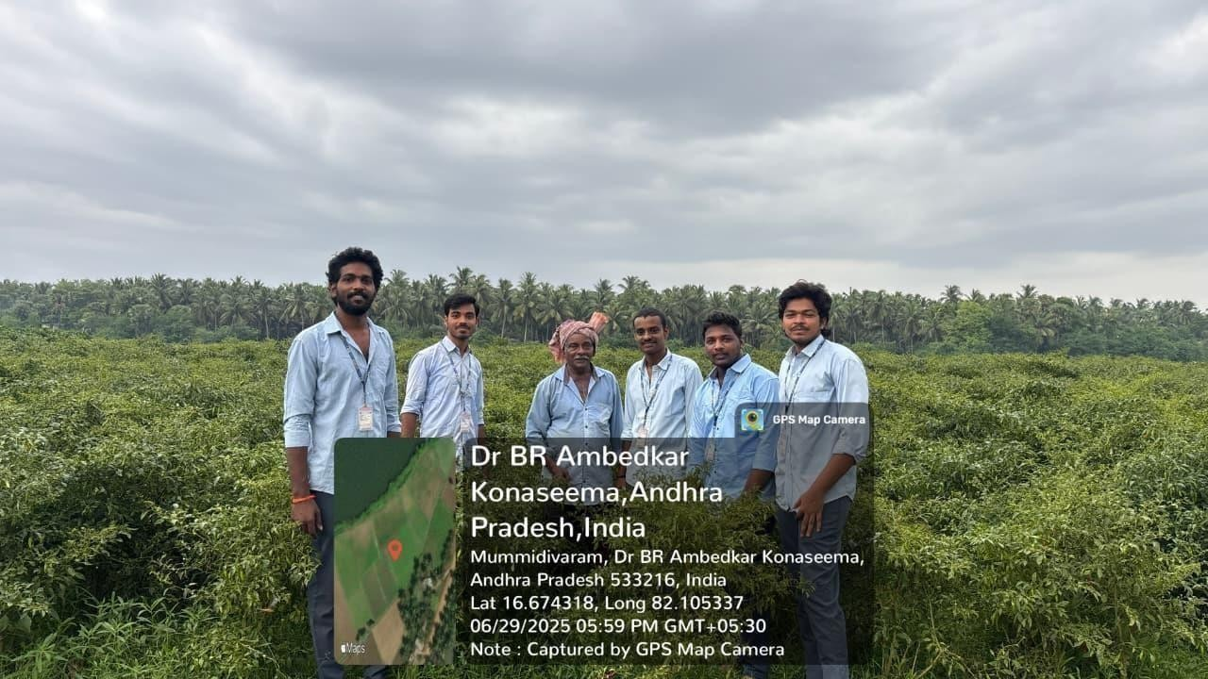

CHAPTER 4: ACTIVITY LOGS

ACTIVITY LOG FOR THE FIRST WEEK

Day  &  Date | Brief description of the daily activity | Learning Outcome | Person In-  Charge  Signature
Day – 1 | We met a Mummidivaram village Sachivalayam VRO to take permission for project. | We know the necessity of crop rotation.
Day – 2 | We have collected data of total crops & total land of village. | . We know various types of crops farming in agriculture.
Day – 3 | We went to agricultural fields for visiting the villages. | We know various types of soils & crops.
Day-4 | We interacted with farmers & asked about how they do farming. | We know that farming is mostly done in organic way
Day – 5 | Enquired about water sources of village for crop farming | The water source is from rivers, canals, and bores.
Day – 6 | We interacted with farmers and created awareness about vermi compost. | We know that vermi compost is very useful to agricultural practices

WEEKLY REPORT

WEEK – 1 (From to )

Objective of the Activity Done:
Detailed Report :
My mentor explained about my community service project and he explained about topic
and guidelines of project, ppt, survey form and report. Then he divided into groups and
select title and plan project.

My group members discussed on permission letter and we taken letter from our mentor

and then we went to our selected village. For gather more information we have interacted
with farmers and asked about varieties of crops which they are farming and contemporary
agricultural practices.

ACTIVITY LOG FOR THE SECOND WEEK

Day  &  Date | Brief description of the daily activity | Learning Outcome | Person In-  Charge  Signature
Day – 1 | We interacted with farmers to bring awareness about vermi compost. | We know that vermi compost is very useful to crops.
Day – 2 | We interacted with agricultural farmers to know types of farming. | .  We know that mostly of them are farming in agricultural seasonal crops
Day – 3 | We interacted with farmers to know about crop rotation process. | We know that the crop rotation farming is useful for soil health
Day -- 4 | We interacted with farmers to visit the agricultural land. | We know that various types of soil in lands.
Day – 5 | We interacted with farmers to know about water resources of village. | The water source is from rivers, lakes for farming.
Day – 6 | We interacted with farmers to bring awareness on crop rotation. | We know that crop rotation is very useful to soil.

WEEKLY REPORT

WEEK – 2 (From to )

Objective of the Activity Done:
Detailed Report:
All members in my batch asked them about water sources and crop rotation process is
available (or not). They said that crop rotation process is available. We asked them
how much time will be taken for one crop period. They said 4 to 6 months of time
period for completion of one crop. We asked them about sources of water for farming.

ACTIVITY LOG FOR THE THIRD WEEK

Day & Date | Brief description of the daily activity | Learning Outcome | Person In- Charge  Signature
Day-1 | We interacted with the farmers to bring awareness about vermi compost. | We know vermi compost is very useful to crops.
Day-2 | We interacted with farmers to know types of farming. | We know that mostly of them are farming in organic.
Day-3 | We interacted with farmers to know about crop rotation process. | We know that crop rotation farming is useful for soil health.
Day-4 | We interacted with farmers to visit agricultural land. | We know that various types of soil in lands.
Day-5 | We interacted with farmers to know about water sources of village | The water source is from rivers for farming.
Day-6 | We interacted with farmers to bring awareness of crop rotation. | We know that crop rotation is very useful to soil.

WEEKLY REPORT

WEEK – 3 (From to )

Objective of the Activity Done:
Detailed Report:
All my batch members asked farmers about crop rotation process and we discussed
with the farmers about the process of crop rotation and its advantages. We explained
about necessity of crop rotation and we explained procedure of crop rotation and use
of crop rotation which increases the health of soil naturally without any inputs.

ACTIVITY LOG FOR THE FOURTH WEEK

Day & Date | Brief description of the daily activity | Learning Outcome | Person  In-  Charge Signature
Day-1 | We interacted with farmers to bring awareness about vermi compost | We know that vermi compost is very useful to crops.
Day-2 | We interacted with farmers to know types of farming in contemporary agricultural practices. | We know that mostly of them are farming in organic way.
Day-3 | We interacted with farmers to know about crop rotation process. | We know that crop rotation farming is useful for soil health..
Day-4 | We interacted with farmers to visit agricultural land. | We know that various types of soil in lands.
Day-5 | We interacted with farmers to know about water source of  village | The water source is from  Godavari rivers for farming.
Day-6 | We interacted with farmers to bring awareness on crop rotation. | We know that crop rotation is very useful to soil.

WEEKLY REPORT

WEEK – 4 (From to )

Objective of the Activity Done:
Detailed Report:
We heard all problems of farmers, what they are facing in farming. We introduced
methods of crop farming for good yields. By simple methods, we conducted a program
.
about crop rotation for awareness of farmers. We talked to Sarpanch about problems
faced by farmers and we gave suggestions to municipal Sarpanch about crop rotation

ACTIVITY LOG FOR THE FIFTH WEEK

Day & Date | Brief description of the daily  activity | Learning Outcome | Person In- Charge  Signature
Day-1 | We interacted with farmers to bring awareness about vermi compost of crops. | We know that vermi compost is very useful to crops.
Day-2 | We interacted with farmers to know about crop rotation process. | we know that crop rotation farming is useful for soil health.
Day-3 | We went to know about different types of crops are farming. | We know various types of crops farming in organic way.
Day-4 | We interacted with farmers to visit agricultural land. | We know that various types of soils in lands.
Day-5 | We interacted with farmers to know about water source of village. | The water source is from rivers for farming.
Day-6 | We interacted with farmers to bring awareness on crop rotation. | We know that crop rotation is very useful to soil and agricultural practices

WEEKLY REPORT

WEEK – 5 (From to )

Objective of the Activity Done:
Detailed Report:
All my batch members asked farmers about crop rotation process and we discussed with
the farmers about the process of crop rotation. We heard all problems of farmers and what
they are facing in farming. We introduced methods of crop farming for good yields and
simple methods. We conducted a program about crop rotation for awareness of farmers.
We talked to Sarpanch about problems faced by farmers and we gave suggestions to
Sarpanch about crop rotation.

31

ACTIVITY LOG FOR THE SIXTH WEEK
Day & Date | Brief description of the daily activity | Learning  Outcome | Person In- Charge  Signature
Day-1 | We researched about contemporary agricultural practices and crop rotation. | We know the necessity of crop rotation.
Day-2 | We went to agricultural fields for visiting the soil. | We know various types of soils.
Day-3 | We learned which types of crops are being farmed. | We know various types of crops farming in organic way
Day-4 | We learned about crops farming in which way. | We know crops are farming in organic way.
Day-5 | We examined the water source for crop farming and contemporary agricultural practices. | The water source is from rivers and canals (Godavari).
Day-6 | We learned about crop rotation and created awareness about crop rotation. | We presented our mini project.

WEEKLY REPORT

WEEK – 6 (From to )

Objective of the Activity Done:
Detailed Report:
Finally, we researched about crop rotation. We learned which types of pesticides are used
in crop rotation. We learned about various types of crops farming in an organic way. We
also learned how much water is utilized for cultivation. We also noted whether conditions
are suitable for crops. We prepared our mini project.

33

ACTIVITY LOG FOR THE SEVENTH WEEK
Day & Date | Brief description of the daily activity | Learning  Outcome | Person In- Charge  Signature
Day – 1 | We interacted with farmers to review crop rotation practices followed in the village. | We understood the importance of proper crop rotation for improving soil fertility.
Day – 2 | We observed different agricultural fields to analyze crop growth. | We learned how crop growth varies based on soil and water availability.
Day – 3 | We collected data about types of fertilizers and pesticides used by farmers. | We understood the difference between organic and chemical farming methods
Day – 4 | We interacted with farmers to understand irrigation methods | We learned about irrigation techniques like canal and borewell systems.
Day – 5 | We analyzed water sources used for agriculture in the village | We understood the importance of water management in farming
Day -6 | We created awareness among farmers about sustainable farming practices. | We learned how awareness programs help farmers improve agricultural productivity

WEEKLY REPORT

WEEK – 7 (From to )

Objective of the Activity Done: To study advanced agricultural practices and interact with farmers to understand real-time farming challenges.
Detailed Report:
During this week, we interacted with farmers to understand crop rotation practices and
observed agricultural fields. We collected information about fertilizers and pesticides
used in farming and studied irrigation methods. We also analyzed water resources
available for farming and created awareness among farmers about sustainable
agricultural practices. This helped us gain practical knowledge about improving crop
yield and maintaining soil health.

ACTIVITY LOG FOR THE EIGTH WEEK

Day & Date | Brief description of the daily activity | Learning  Outcome | Person In- Charge  Signature
Day – 1 | We reviewed all collected data from farmers and fields. | We understood how to organize and analyze agricultural data.
Day – 2 | We worked on preparing the final project report. | We learned how to document fieldwork in a structured format.
Day – 3 | We prepared charts and presentations for the project. | We improved our presentation and documentation skills.
Day – 4 | We discussed project findings with team members and mentors | We learned teamwork and collaborative problemsolving skills.
Day – 5 | We finalized the project report and verified all details. | We understood the importance of accuracy and completeness in reports.
Day -6 | We presented our final CSP project. | We gained confidence in presenting and explaining our project work.

35

WEEKLY REPORT

WEEK – 8 (From to )

Objective of the Activity Done: To compile, analyze, and present the findings of the community service project.
Detailed Report:
In this week, we organized all the collected data and prepared the final project report.
We created charts and presentations to represent our findings. We discussed the results
with our team members and mentors. Finally, we completed and presented our CSP
project successfully. This week helped us improve our documentation, presentation,
and teamwork skills
36

CHAPTER 5

OUTCOMES DESCRIPTION
This chapter presents the results and findings of the socio-economic survey conducted in Mummidivaram village, highlighting the major problems identified, short- and long-term solutions, awareness campaigns, and survey analysis. The project focuses on “Agriculture and Its Impact on Farmers.”

5. Socio-Economic Survey Details
The socio-economic survey was conducted in Mummidivaram village, Mummidivaram Mandal, Konaseema District, Andhra Pradesh.
Before starting, permission was taken from village officials to interact with farmers directly in their fields.

The main objective of the survey was to understand:
- Farmers’ income, resources, and challenges.
- The effect of agriculture on their economic stability.
- Their awareness of modern farming methods and government schemes.

Questionnaire Highlights
- Farmer’s Name
- Father’s Name
- Village Name
- Land Area (Acres)
- Ownership Status (Self/Leased)
- Annual Income
- Is income sufficient for the family?
- Any losses faced?
- Are you getting reasonable prices for your crops?
- Any pest attacks?

- Water problems?

- Other major issues?
- Required changes?
- Any issues to bring to government notice?
15.

5.1 Short-Term Solutions

Probl em  Area | Proposed Short-Term  Action | Expected Outcome
Irrigat ion | Construct small farm ponds and rainwater tanks | Water available for next crop cycle
Crop  Loss | Introduce Plantix App for pest and weather alerts | Reduce crop damage and increase awareness
Water Usage | Adopt drip irrigation systems | Efficient use of limited water
Low  Yield | Use seaweed extract (4–5 kg/acre) | Improved soil fertility and higher yield
Price Fluct uation | Promote direct farmer-to- market sales | Better profits for farmers

5.2 Long-Term Solutions
- Petition submitted to Agricultural Officer and Village Sarpanch regarding fair pricing and irrigation facilities.
- Request for new bore-wells and pump sets to ensure reliable irrigation.
- Formation of Farmer Co-operatives to avoid miller exploitation.
- Organize continuous training on organic and smart farming practices.
- Promote construction of storage facilities to preserve grains and sell when market prices rise.

5.3 Community Awareness Programs
The Geographical location Mummudivaram village:
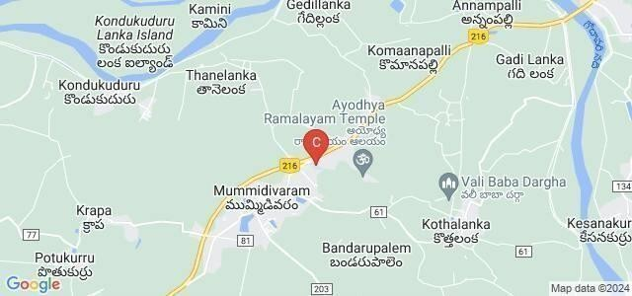

5.3.1 Community Awareness Program – 1
- Location: Near Sachivalayam, Lakkavaram
- Topic: Problems and solutions in agriculture
- Activities: Discussion on pricing issues, irrigation challenges, pest management, and flood control.
- Outcome: Farmers showed interest in drip irrigation and Plantix app usage.

5.3.2 Community Awareness Program – 2
- Location: Village Green Fields
- Topic: Use of modern agriculture techniques and water management.
- Outcome: Farmers actively participated and agreed to adopt seaweed extracts and drip irrigation.

5.4 Mini-Project Report
- Project Title: Agriculture and Its Impact on Farmers
- Village: Lakkavaram, Malkipuram Mandal, Konaseema District • Around 1,200+ families depend on agriculture as the main livelihood.
- Major crops: Paddy and Coconut.
- Total area under cultivation: Approx. 2,400 acres. Sample Survey Data

5.5 Major Findings and Impacts
- Farmers face economic loss due to low market prices and miller dependency.
- Pest attacks and water shortages affect productivity.
- Lack of health facilities and delayed payments cause financial stress.
- Awareness programs increased farmers’ knowledge of modern techniques.
- Community and government officials

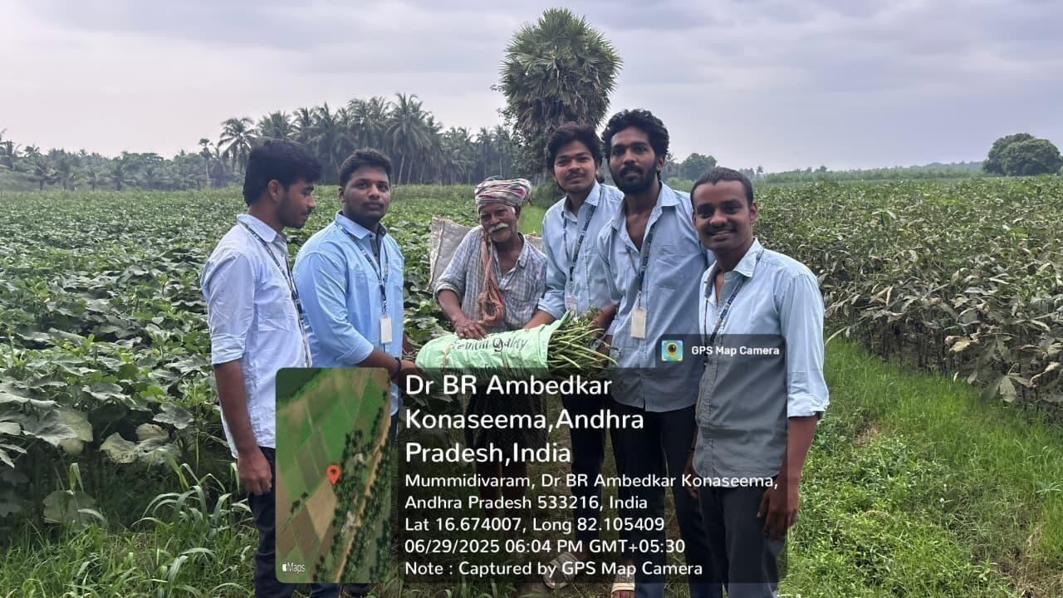

CHAPTER 6

RECOMMENDATIONS AND CONCLUSIONS OF THE MINI PROJECT

6. Overview
After the successful completion of the awareness campaigns and survey in the village, several important insights and outcomes were observed regarding agricultural practices and the problems faced by the farmers. The campaigns created awareness among the villagers about sustainable farming practices, efficient water usage, and modern farming technologies.

6.1 Recommendations
6.1 Promotion of Organic Farming
Farmers were encouraged to adopt organic farming methods instead of relying heavily on chemical fertilizers and pesticides. Organic farming helps maintain soil fertility, ensures long- term sustainability, and improves the quality of crops.

6.2 Conclusion
- After conducting the socio-economic survey and awareness campaigns, it was observed that:
- The farmers gained valuable knowledge about modern farming practices and sustainable agriculture.
- They understood the importance of water conservation, pesticide management, and organic farming.
- The introduction of the Plantix App was found very useful for identifying crop diseases and improving productivity.
- The farmers showed great enthusiasm and willingness to learn and apply new techniques.

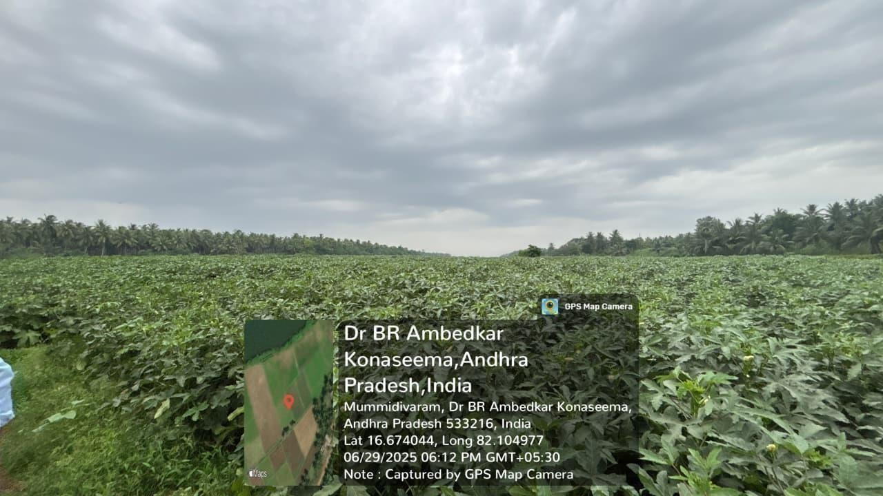

Photos

Figure-1: Intracting with farmer

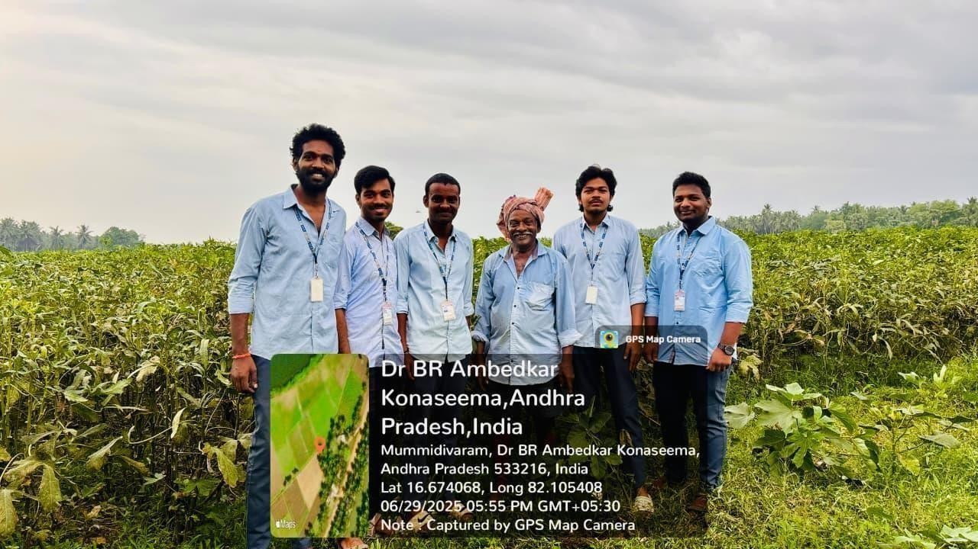

Figure-2: Explaining About New techniques

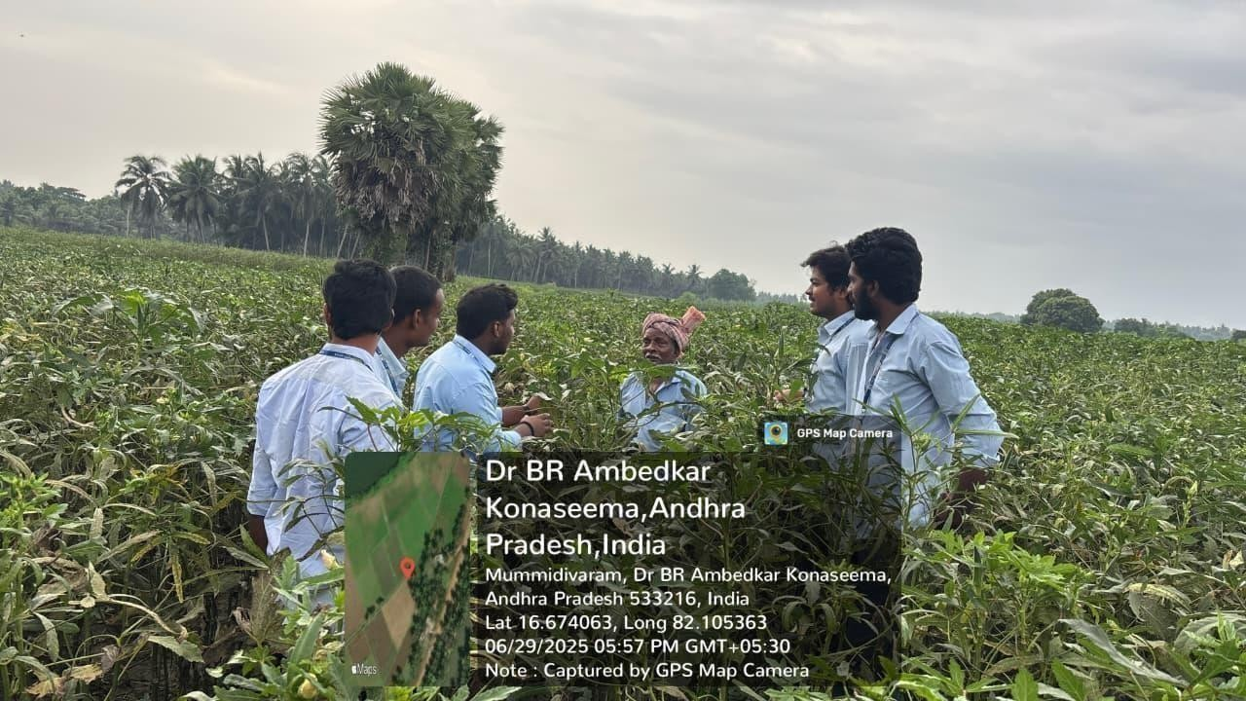

Figure-3 : Intracting with farmer

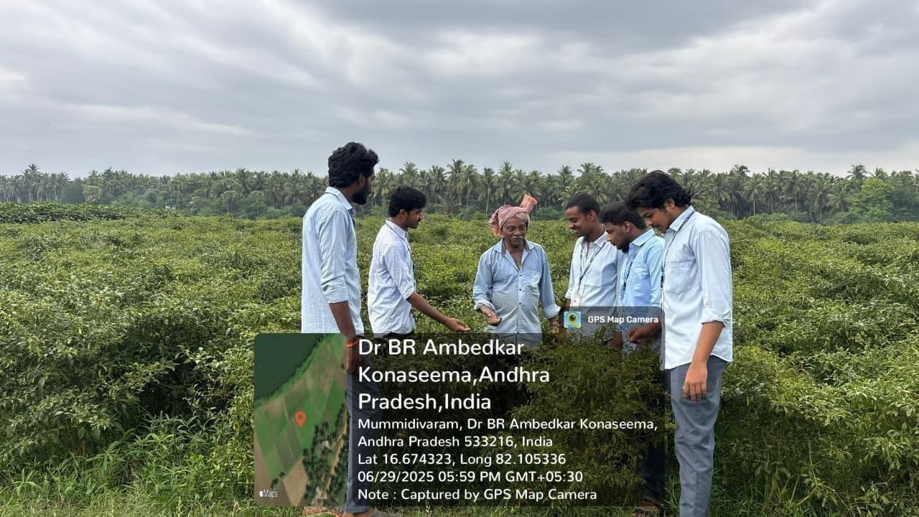

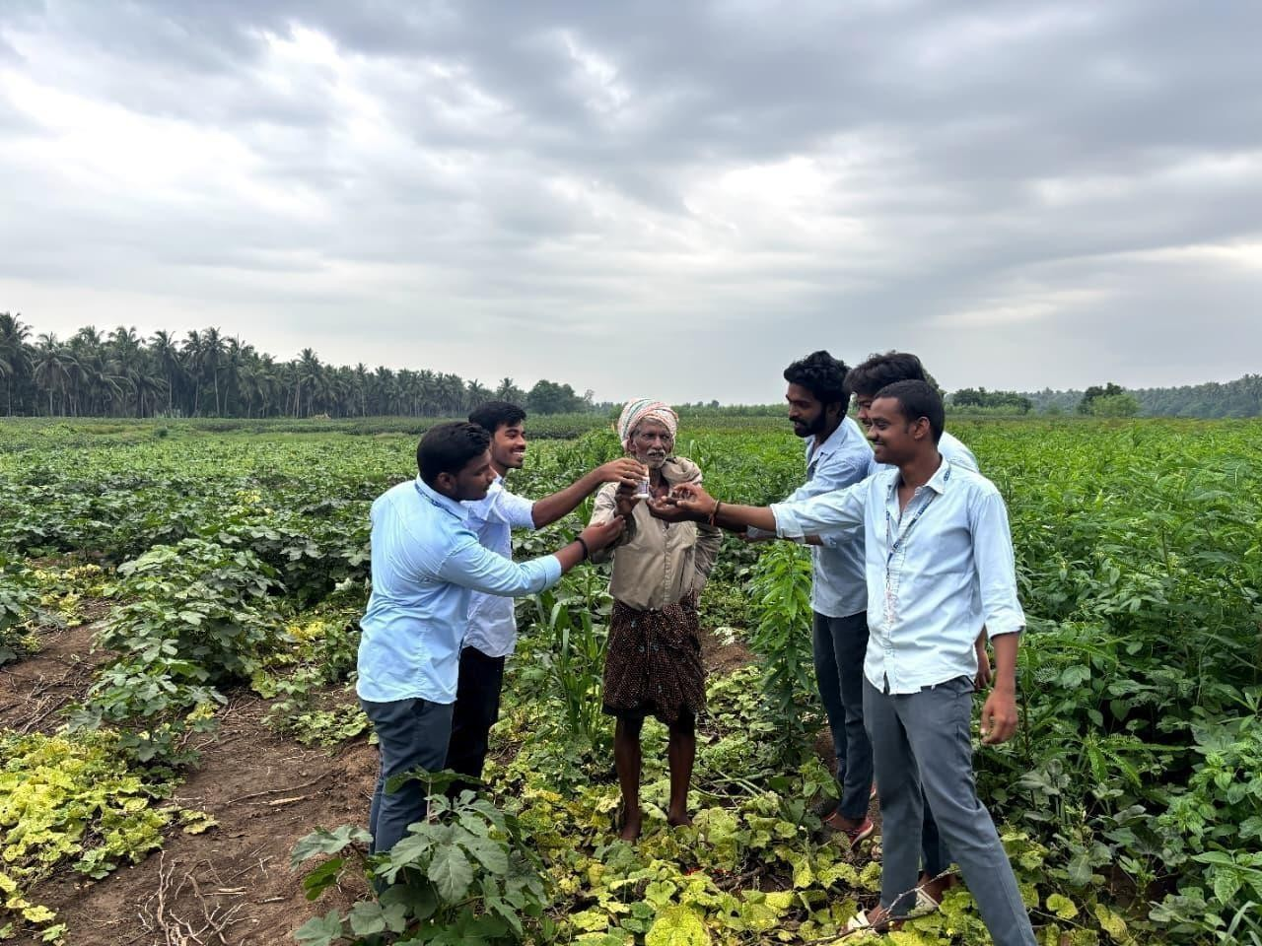

EVALUATION

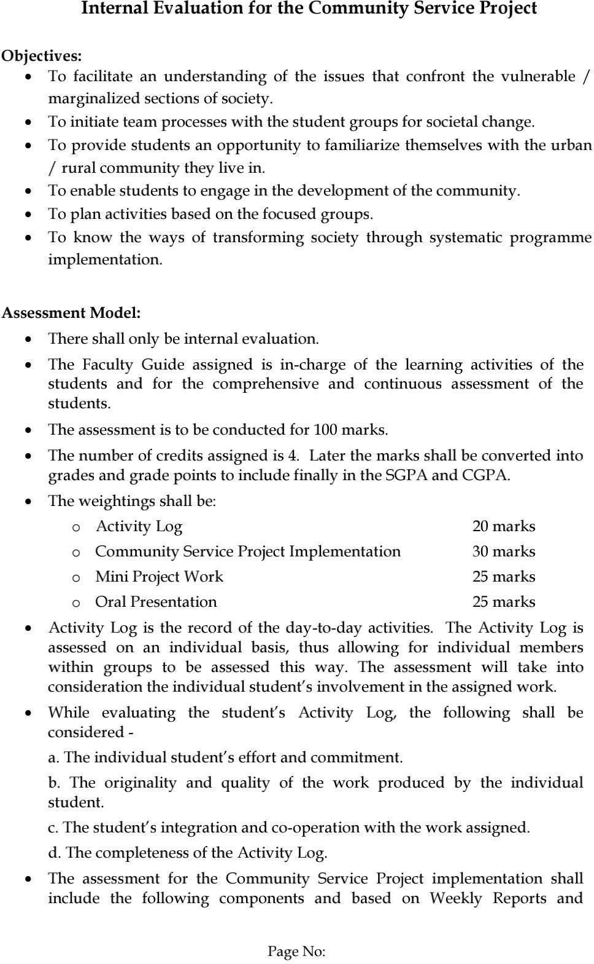
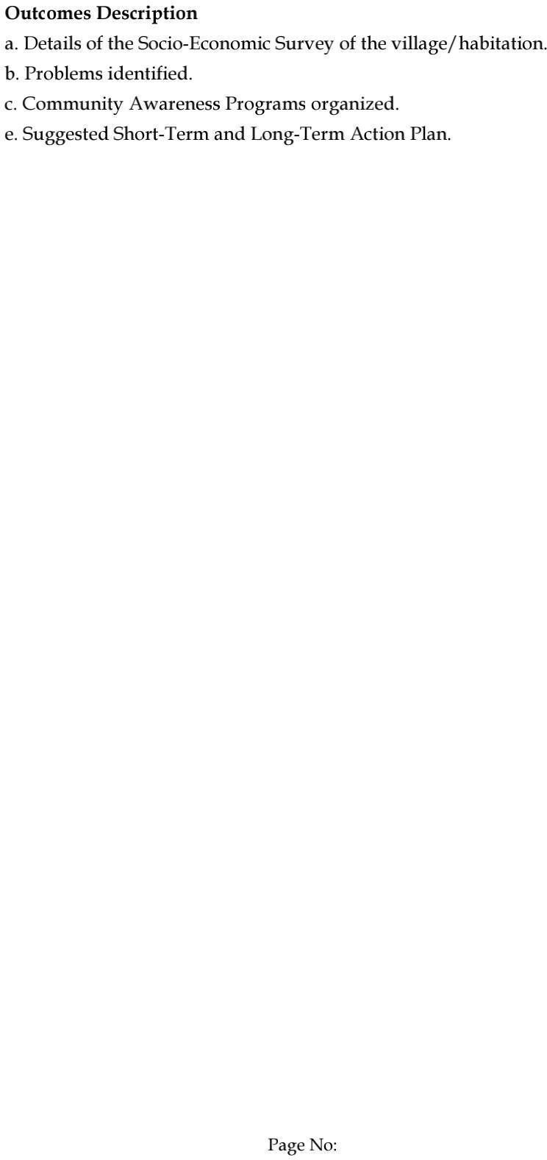

MARKS STATEMENT
(To be used by the Examiners)

